Connecting to your Windows Instance
To connect to the Windows instance you will use a RDP client. If you use Windows as your local computer, use the bundled Remote Desktop application. For Mac users, if you don’t have a RDP client already installed, download Microsoft Remote Desktop .

Locate your web server by navigating to the Amazon EC2 console and selecting Instances in the left side menu.

Click the checkbox next to your web server, then click the Connect button.

Select the RDP client tab and then click Get password to retrieve your Windows administrator password, which has been automatically generated and encrypted.

Click the Upload private key file button and select the private key file that you downloaded earlier when you created your new key pair.

Select Decrypt Password.

The decrypted administrator password will be a random combination of letters, numbers, and special characters. Take note of this password, as you will need it later.

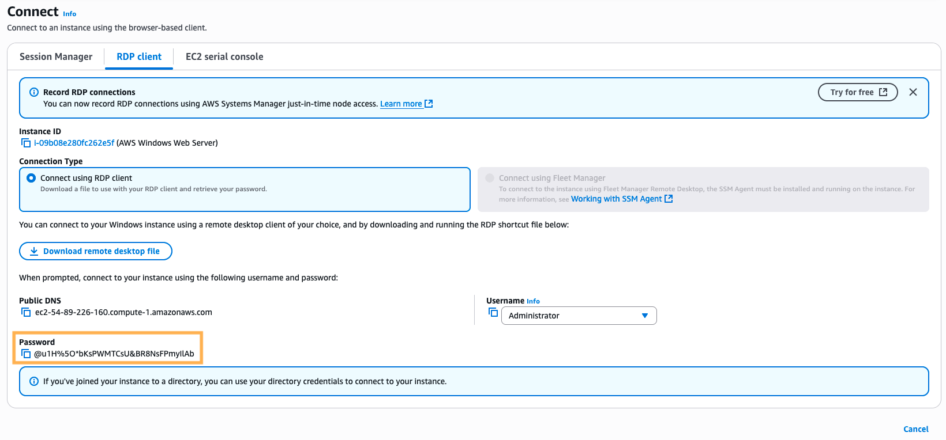

Note that since only you have the private key, it’s important to understand the automatically generated password can only be decrypted by you. So it’s important to keep this key secure. Generally, the automatically generated password is changed by the customer after first login. If the automatically generated password is not changed and the private key is lost, there’s no way to recover the password.

Start your RDP application and connect to the hostname of your instance.

The hostname of your instance can be found in the Connect to instance window from the previous step, on the RDP Client tab, under Public DNS..

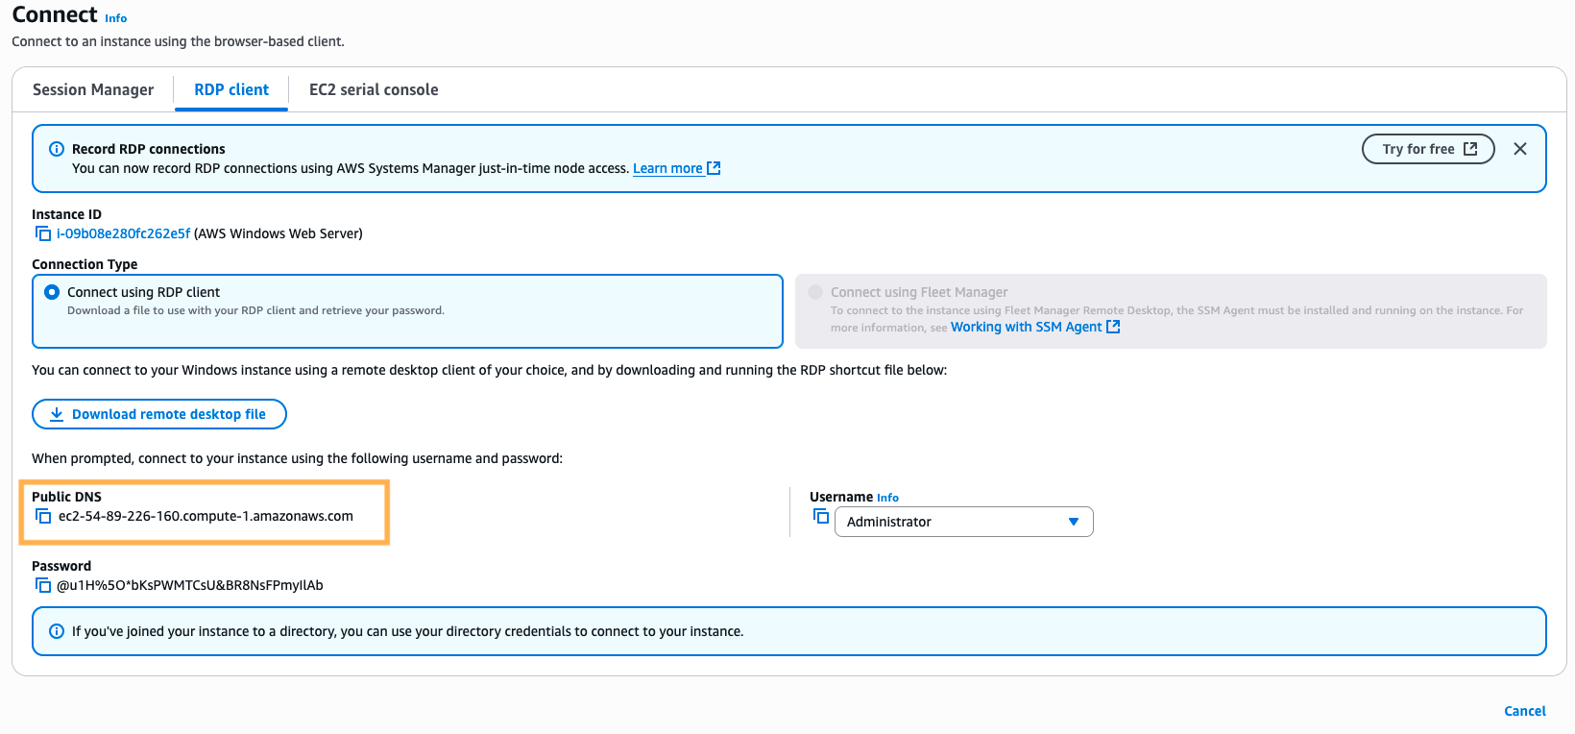

You can also find it by navigating to the Amazon EC2 console and selecting Instances in the left side menu. Click the checkbox next to your web server and locate Public DNS in the Details tab under Instance summary.

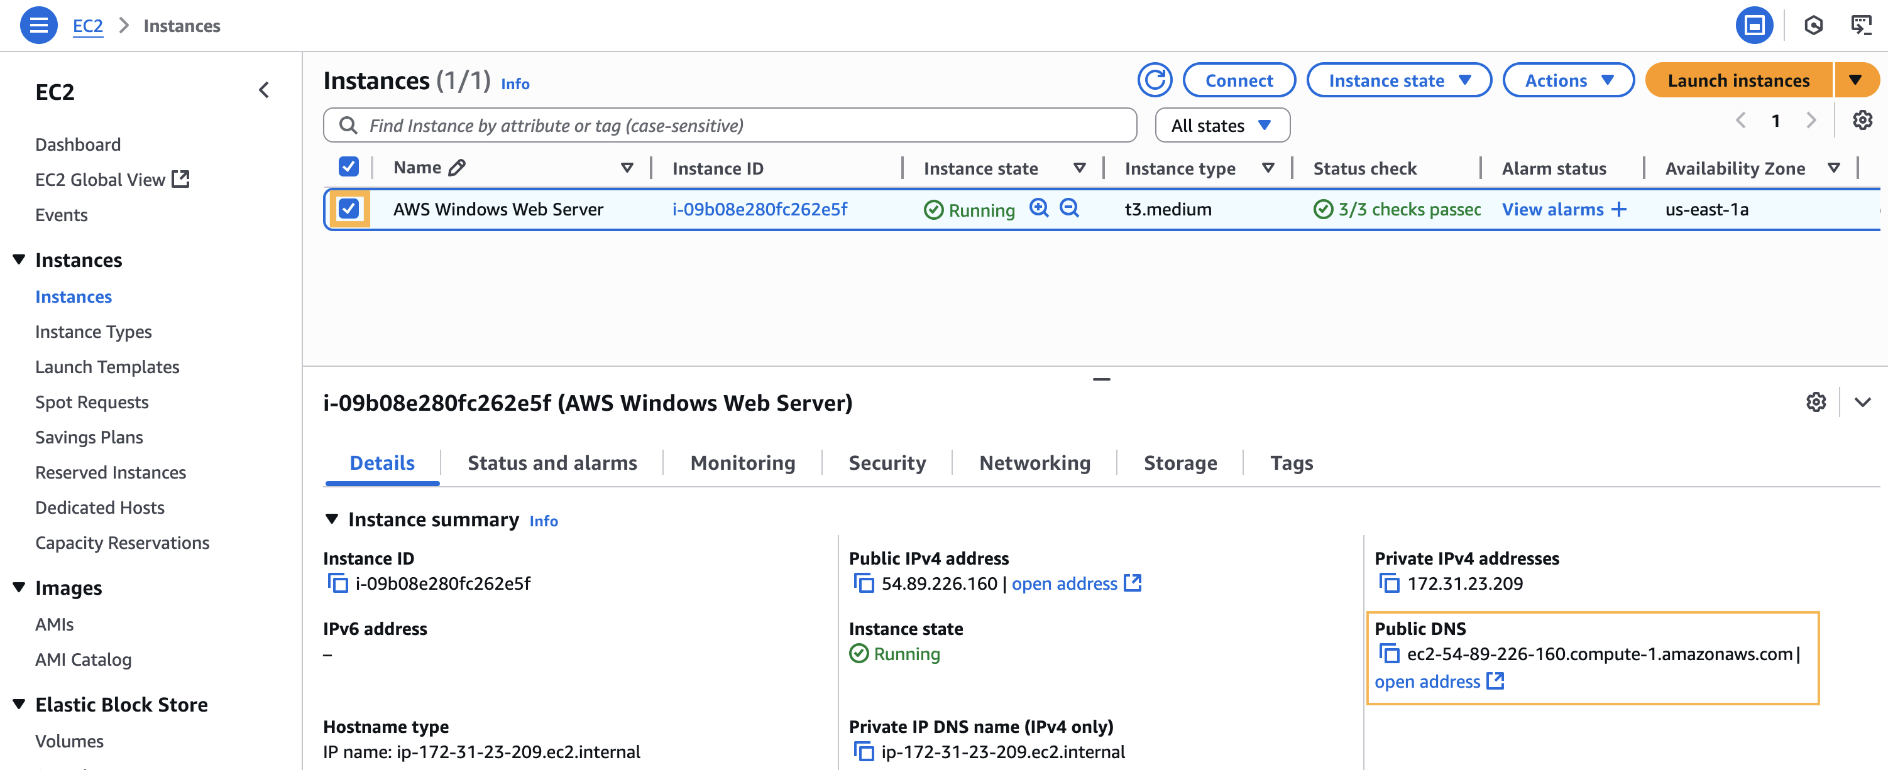

Once your RDP session is established, a Windows desktop will appear with a background similar to the one shown below.

Great Job
You have connected to your Windows EC2 Instance.

Learning Recap

In this section, you created an SSH key pair to securely access your EC2 Windows instance. You then launched a Windows Server 2022 instance with IIS installed and configured a simple web page. To verify the web server was working, you browsed to the public DNS address and viewed the web page. Finally, you connected to your Windows instance using RDP and the decrypted administrator password.
Through hands-on exercises, you gained experience with launching, accessing, and managing EC2 Windows instancesXvXTnA=tevsQ@S1=JfvSlWf-

